**PokéMon MASTER Fire RED   
By Master Poucine**

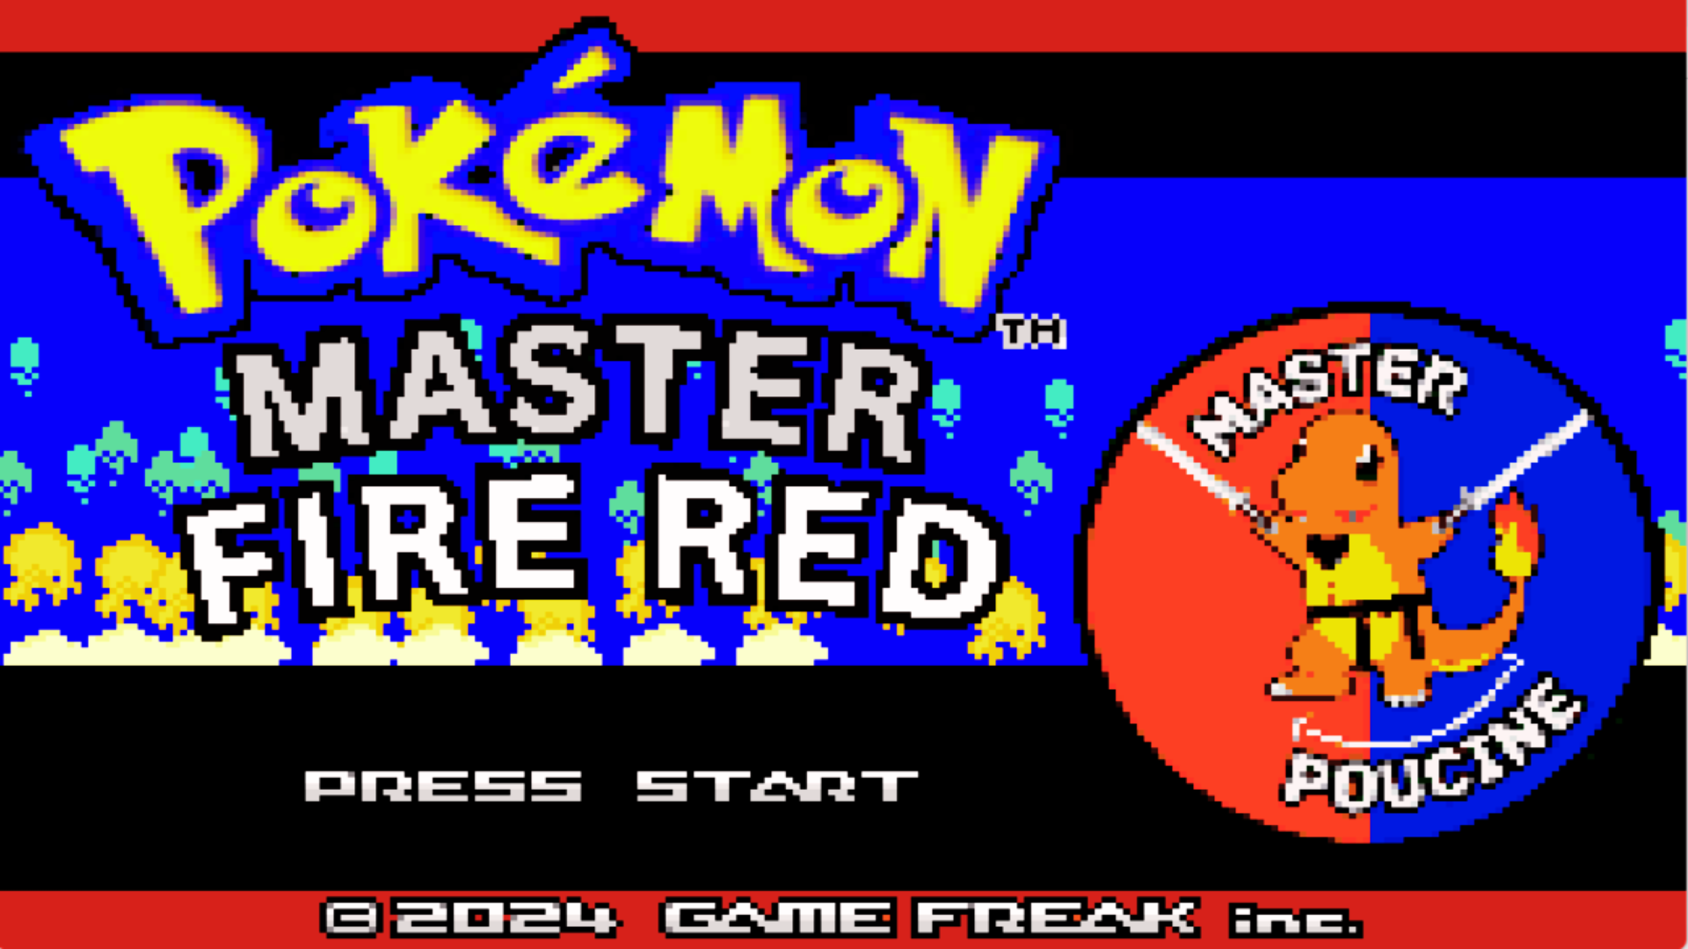

**Introduction : Hi It’s Your Boy Master Poucine I’ve been playing and Nuzlocking Romhacks For over 2 years on My Youtube Channel And I feel In love with it.  
I’ve always dreamt of creating my own RomHack and today I present to you My own creation Pokémon Kanto Fire RED.   
  
What is Kanto Fire RED, it’s a GBA RomHack of FireRED with only the first 151 pokémon all catchable The original pokémon From the first Released Game by Game Freak.  
  
But I was not fully satisfied when I was playing the game. The gym leaders were too easy, the movesets not crazy and even the learnset and the base stats.   
So i decided to change the typing, the abilities, add an easy EV training in the first pokemart (each vitamins give you 40 Ev and it’s capped to 252) also you can buy rare candies for 1 poké same for repels and vitamins no need to grind for hours and all the tms are available from the beginning of the game at the pokemon centers.   
  
Oh wait, that's too easy… No with the teams that i Build for gym leaders rival and Giovanni you will be surprised by the difficulty of the game. I don't recommend Nuzlocking the game for your first playthrough, it's almost impossible (if you want to try to nuzlocke it anyway, here are the level caps).   
  
Master Poucine   
  
Download link : https://www.mediafire.com/file/2flcny45bwuu9oi/PokémonMasterFireRED(V1.01).gba/file  
  
  
Level Caps :   
Brock : 17 / Misty 27 / LT.Surge 34 / Erika 39 / Koga 46 / Sabrina 56 / Blaines 66 / Giovanni 71 / Elite 4 Champion : 85**

**Pokédex Changes :**

| **Pokémon** | **Typing** | **STATS adjustment** | **Abilities** |
| --- | --- | --- | --- |
| **VENUSAUR** |  | **+20 Physical Attack** | **Effect Spore Thick Fat** |
| **CHARIZARD** |  |  | **Flame Body Drought** |
| **BLASTOISE** |  |  | **Shell Armor Drizzle** |
| **BUTTERFREE** |  | **+25 Physical Attack** | **Compound Eyes** |
| **BEEDRILL** |  | **+20 Speed  +10 Attack +10 Special Defense** | **Swarm Poison point** |
| **PIDGEOT** |  |  | **Speed Boost** |
| **RATICATE** |  |  | **Huge Power Guts** |
| **FEAROW** |  |  | **Air Lock Keen Eye** |
| **ARBOK** |  |  | **Intimidate Shed Skin** |
| **SANDSLASH** |  |  | **Sand Stream** |
| **NIDOQUEEN** |  |  | **Intimidate** |
| **NIDOKING** |  |  | **Intimidate** |
| **CLEFABLE** |  |  | **Cute Charm** |
| **NINETALES** |  |  | **Drought** |
| **GOLBAT** |  |  | **Levitate** |
| **PARASECT** | **Bug And Ghost** |  | **Effect Spore** |
| **DUGTRIO** | **Ground and Normal** |  | **Arena Trap Sand Veil** |
| **PERSIAN** |  |  | **Huge Power** |
| **GOLDUCK** | **Water And Psychic** |  | **Cloud Nine Damp** |
| **PRIMEAPE** |  |  | **Intimidate** |
| **ARCANINE** |  |  | **intimidate  Flash Fire** |
| **POLIWRATH** |  |  | **Drizzle** |
| **VICTREEBEL** |  |  | **Intimidate** |
| **TENTACRUEL** |  |  |  |
| **GOLEM** |  |  | **Sand Stream  Rock Head** |
| **RAPIDASH** |  |  | **Speed Boost Flash Fire** |
| **SLOWBRO** |  |  | **Shell Armor Own Tempo** |
| **MAGNETON** |  |  | **Levitate Magnet pull** |
| **FARFETCH’D** |  |  | **Huge Power Speed Boost** |
| **DODRIO** |  |  | **Intimidate Early Bird** |
| **MUK** |  |  | **Poison Point Shadow Tag** |
| **CLOYSTER** |  |  | **Shell Armor** |
| **GENGAR** |  | **130 Physical Attack 110 Special Attack** |  |
| **Onix** |  | **90 HP 95 AttacK** | **Rock Head Sand Stream** |
| **HYPNO** |  |  | **Serene Grace Insomnia** |
| **KINGLER** |  | **130 Attack 130 Special Attack** | **Shell Armor Sand Veil** |
| **ELECTRODE** |  |  | **Speed Boost  Static** |
| **EXEGGUTOR** |  |  | **Thick FAT** |
| **MAROWAK** |  |  | **Rock Head Lightning Rods** |
| **HITMONLEE** |  |  | **Intimidate** |
| **HITMONCHAN** |  | **105 Special Attack** | **Color Change** |
| **LICKITUNG** |  |  | **Huge Power** |
| **WEEZING** |  |  | **Levitate** |
| **RHYDON** | **ROCK NORMAL** |  | **Rock Head Lightning Rods** |
| **TANGELA** |  | **85 HP 100 Attack 115 Def 100 SpAttack 60 Speed 40 Spdef** | **Wonder Guard** |
| **KANGASHKAN** |  |  | **Rock Head** |
| **SEADRA** |  |  | **Intimidate** |
| **SEAKING** | **WATER NORMAL** |  | **Lightning Rods** |
| **Mr.Mime** | **WATER ICE** |  | **Wonder Guard** |
| **SCYTHER** | **BUG** |  | **Swarm** |
| **JYNX** |  |  | **Serene Grace** |
| **ELECTABUZZ** |  |  | **Static** |
| **MAGMAR** |  |  | **Flame Body** |
| **PINSIR** |  |  | **SWARM** |
| **TAUROS** |  |  | **Intimidate Rock Head** |
| **GYARADOS** |  | **60 Attack 125 Special Attack** |  |
| **LAPRAS** |  |  | **Drizzle Sheel Armor** |
| **DITTO** |  | **100 HP 60 in all of his other Stats** | **Battle Armor** |
| **VAPOREON** |  |  |  |
| **FLAREON** |  |  |  |
| **JOLTEON** |  |  |  |
| **PORYGON** |  |  | **Levitate** |
| **OMASTAR** |  |  | **Shell Armor** |
| **KABUTOPS** | **ROCK DARK** |  | **Battle Armor** |
| **AERODACTYL** |  |  | **ROCK HEAD INTIMIDATE** |
| **ARTICUNO** |  |  | **Intimidate** |
| **ZAPDOS** |  |  | **intimidate** |
| **MOLTRES** |  |  | **Drought** |
| **DRAGONITE** |  |  | **LEVITATE** |
| **MEWTWO** |  |  | **Serene Grace Shed Skin** |
| **MEW** |  |  | **Shed Skin Shed Skin** |

**Move Change 👍**

| **MOVE NAME** | **TYPING** | **POWER** | **ACCURACY** | **EFFECTS** |
| --- | --- | --- | --- | --- |
| **POUND** | **normal** | **50** |  |  |
| **Double Slap** | **Normal** | **25** | **100** | **hits 2 to 5 times** |
| **Comet Punch** | **Normal** | **25** | **100** | **hits 2 to 5 times** |
| **Mega Punch** | **Normal** | **85** | **100** |  |
| **Mega Kick** | **normal** | **100** | **100** |  |
| **KARATE CHOP** | **Fighting** | **65** |  | **High Crits** |
| **CUT** | **Steel** | **75** | **100** |  |
| **FLY** | **FLYING** | **95** | **100** |  |
| **Pin missile** | **BUG** | **25** | **100** | **hits 2 to 5 times** |
| **STRENGTH** | **ROCK** | **95** | **100** |  |
| **EGG BOMB** | **grass** | **100** | **100** |  |

**GYM LEADERS AND RIVALS TEAMS :   
  
BROCK : 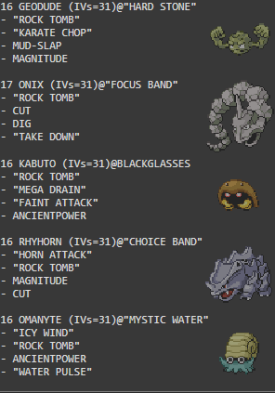  
  
  
MISTY :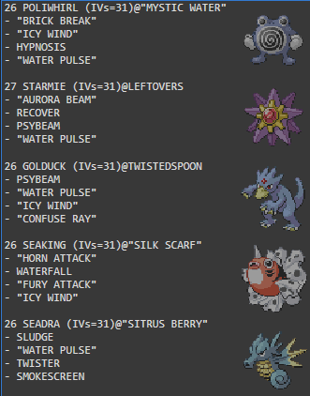  
  
LT.Surge : 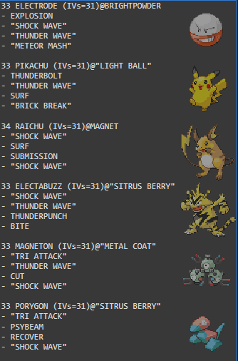  
  
ERIKA : 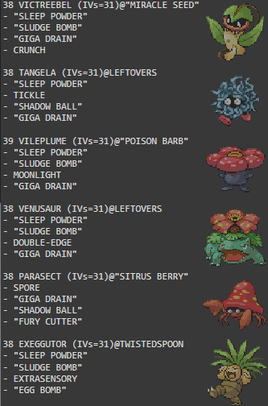  
  
KOGA :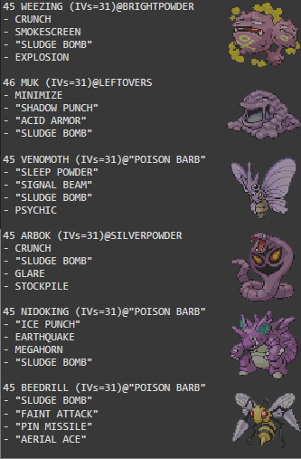  
  
SABRINA : 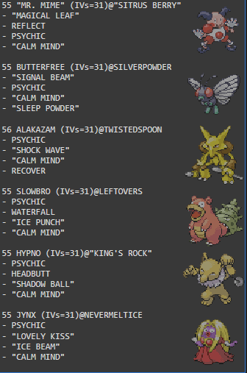  
  
BLAINES :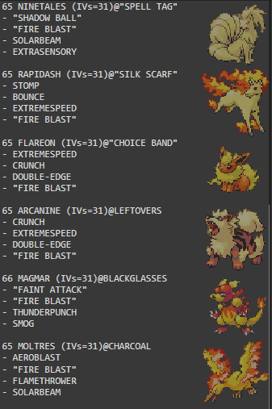  
  
GIOVANNI : 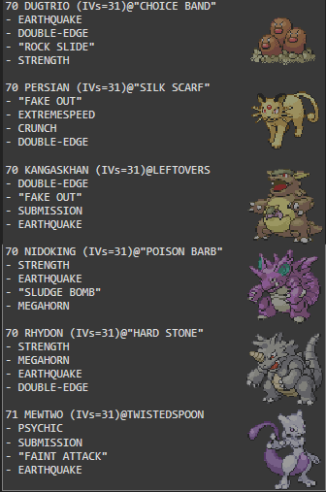  
  
LORELEI (Double Battle) : 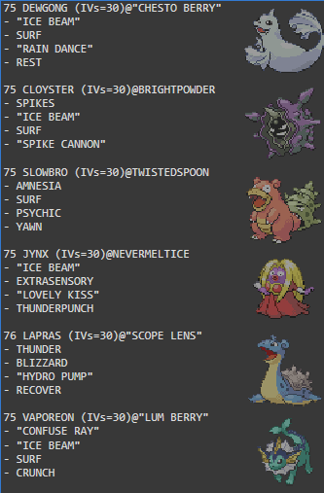  
  
BRUNO : 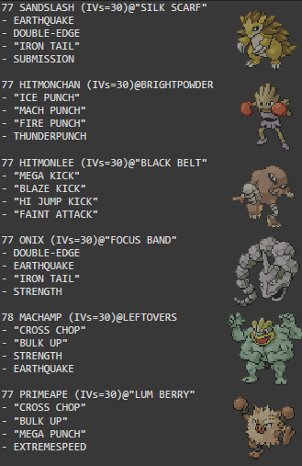  
  
AGATHA :** 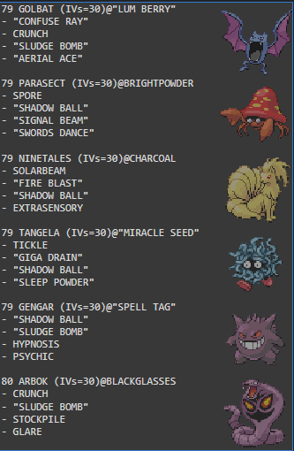

**LANCE :** 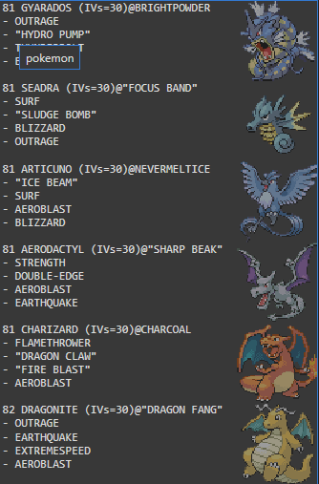

**CHAMPION :  
If you choose Bulbasaur =>  
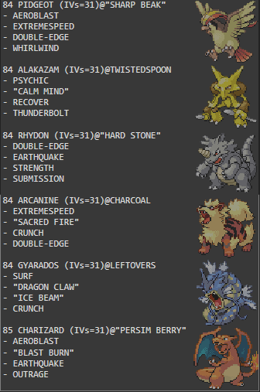  
  
If you Choose Squirtle =>  
  
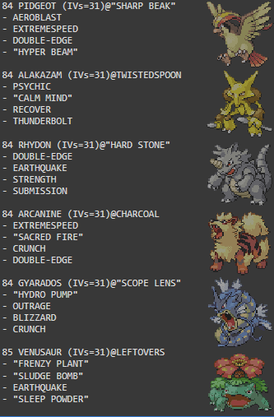  
If you Choose charmander =>**

**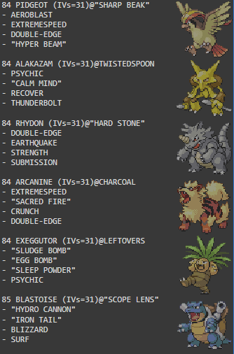  
ALL RIVAL FIGHT :   
If you choose Bulbasaur :**

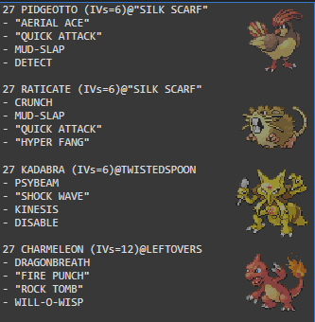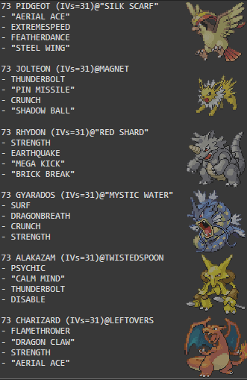

**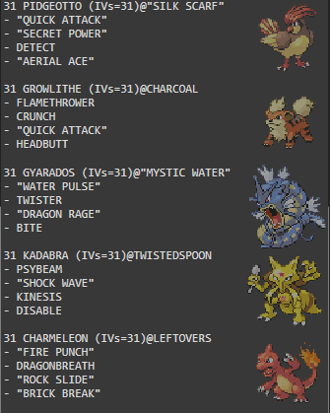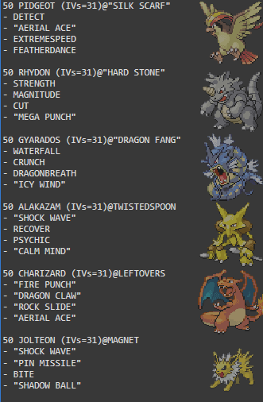  
  
If you choose Squirtle :  
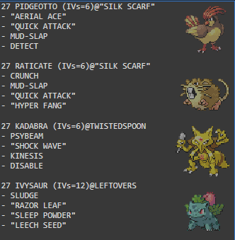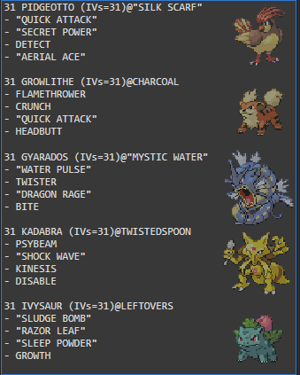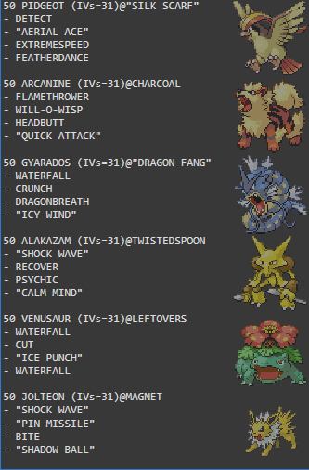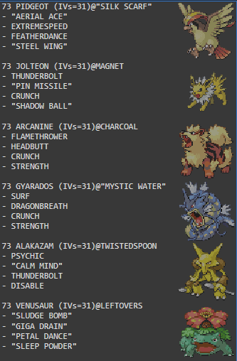  
  
If you Choose Charmander :  
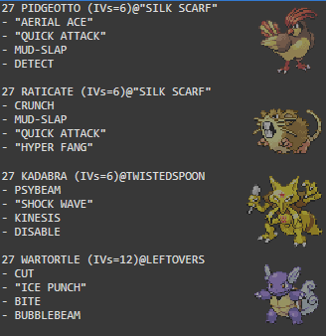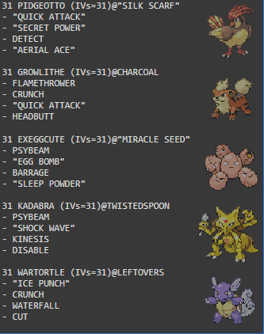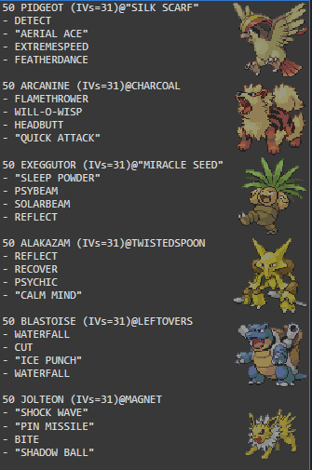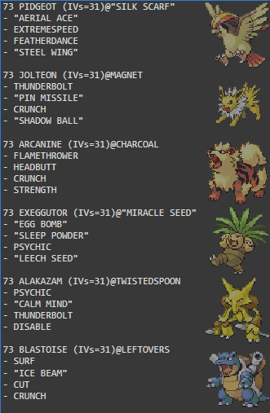  
  
All Giovanni Boss Fights :  
 